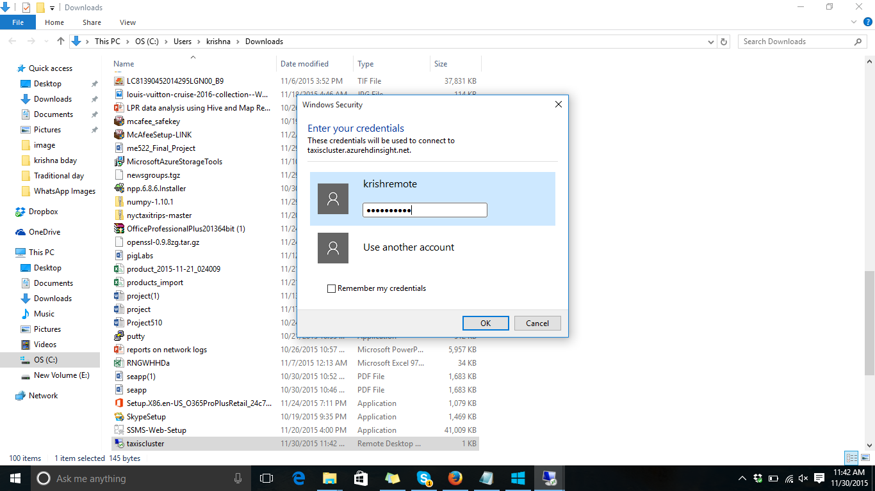

Remote desktop->connect->will download file and use it.

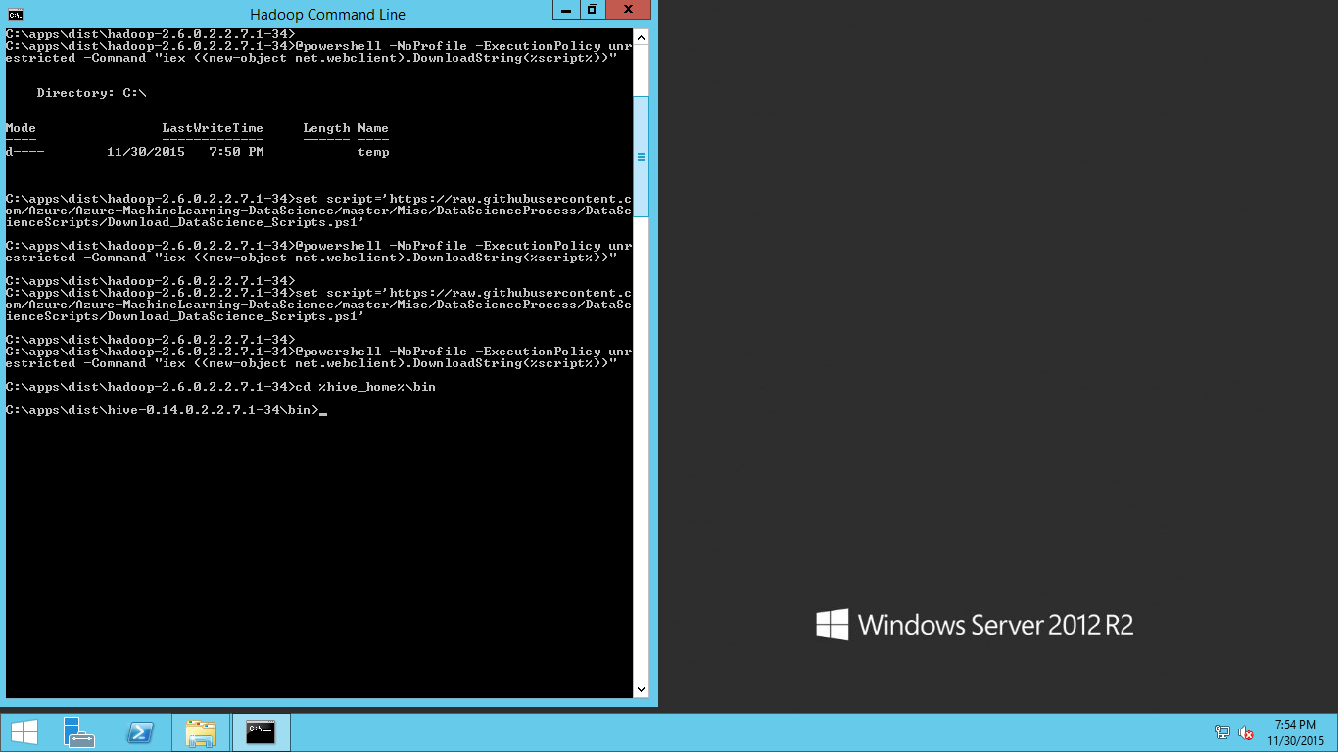

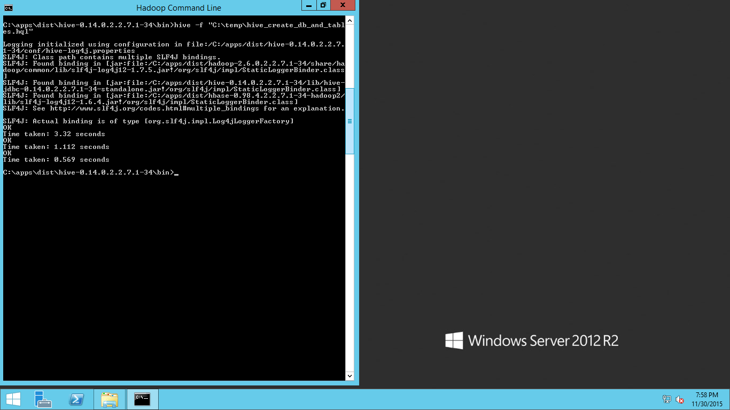

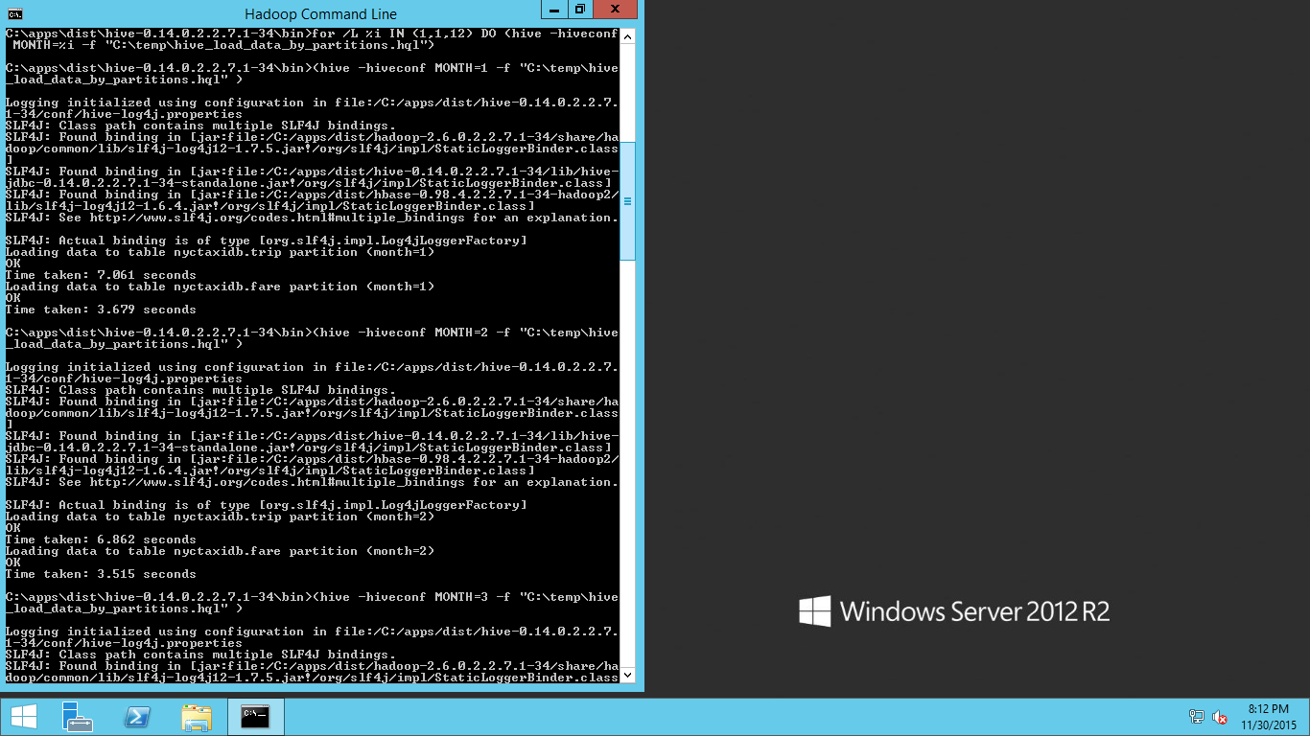

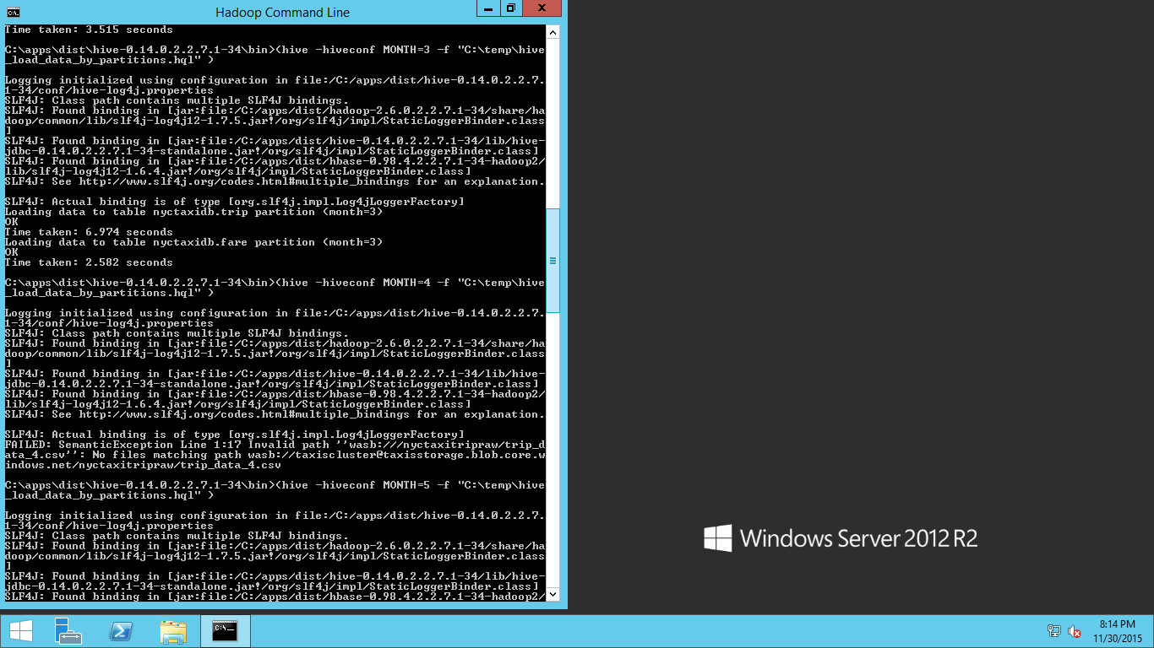

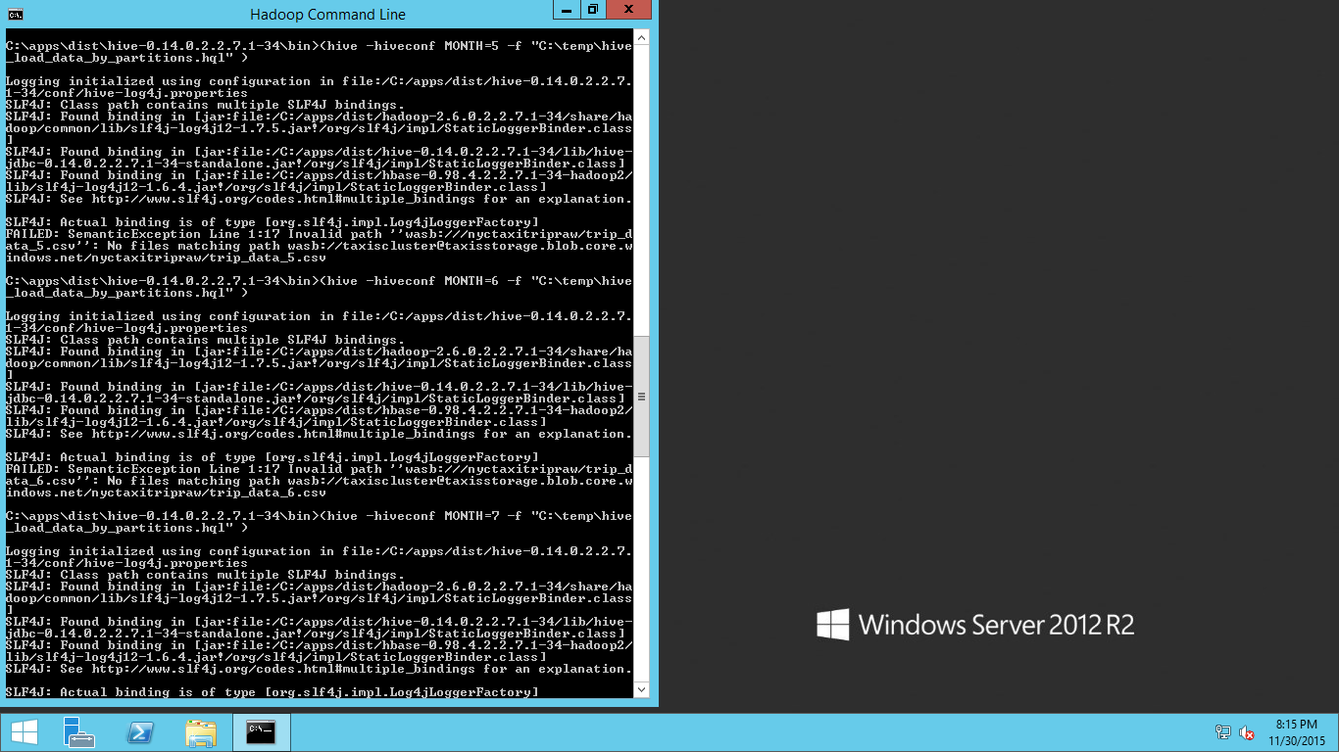

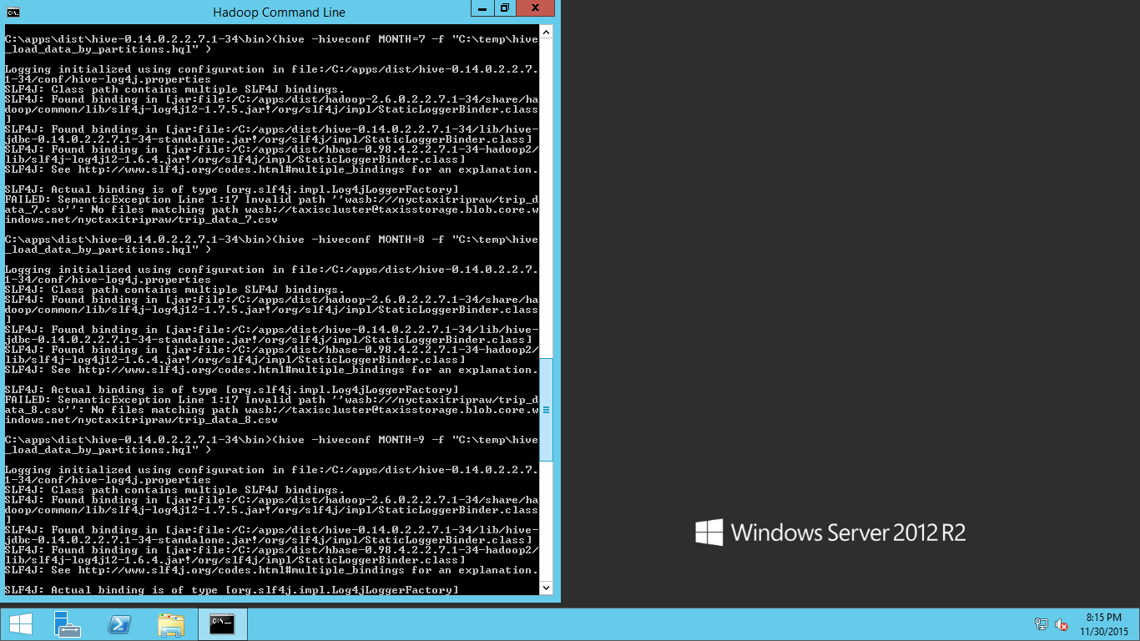

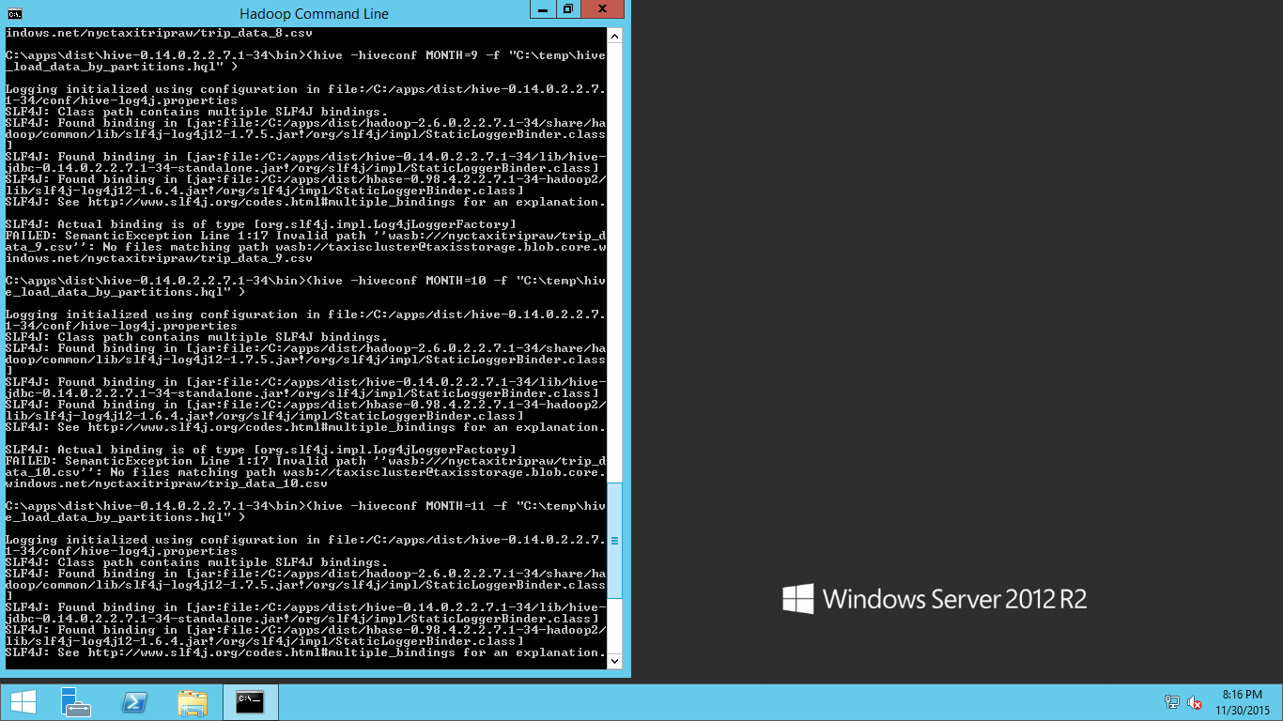

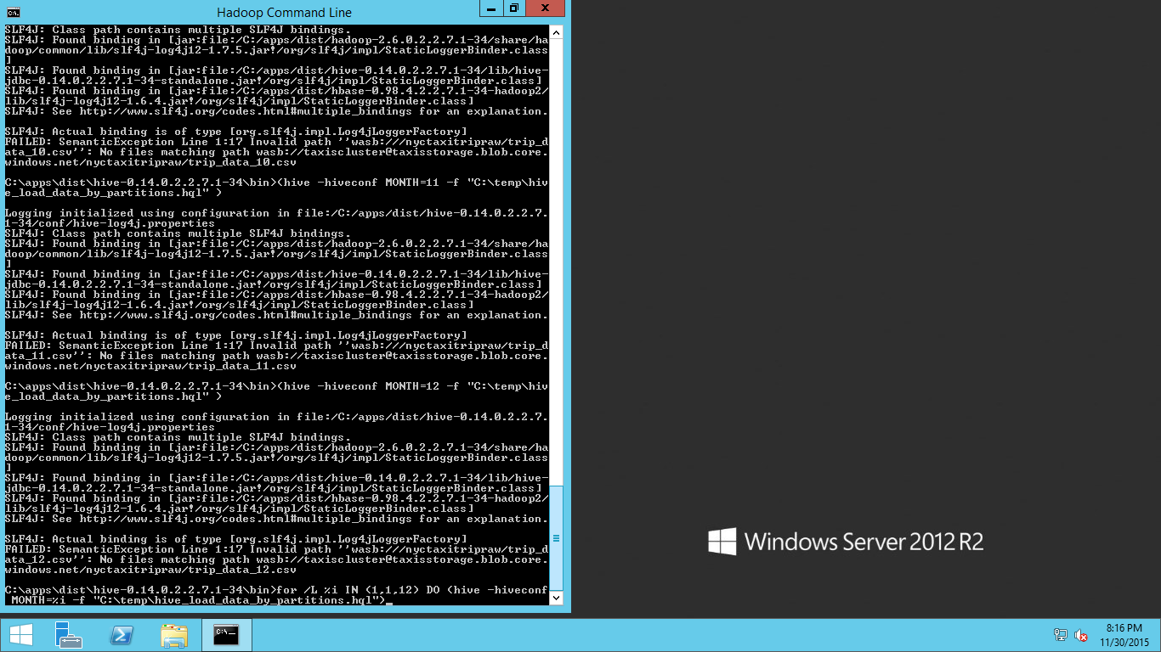

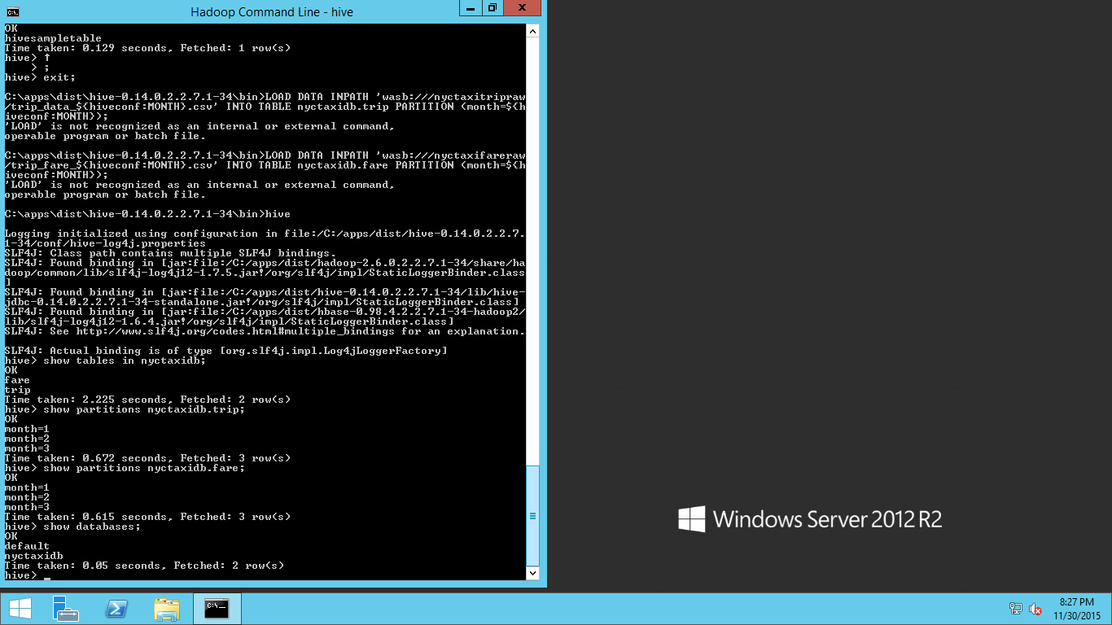

For trip 10 records month 1

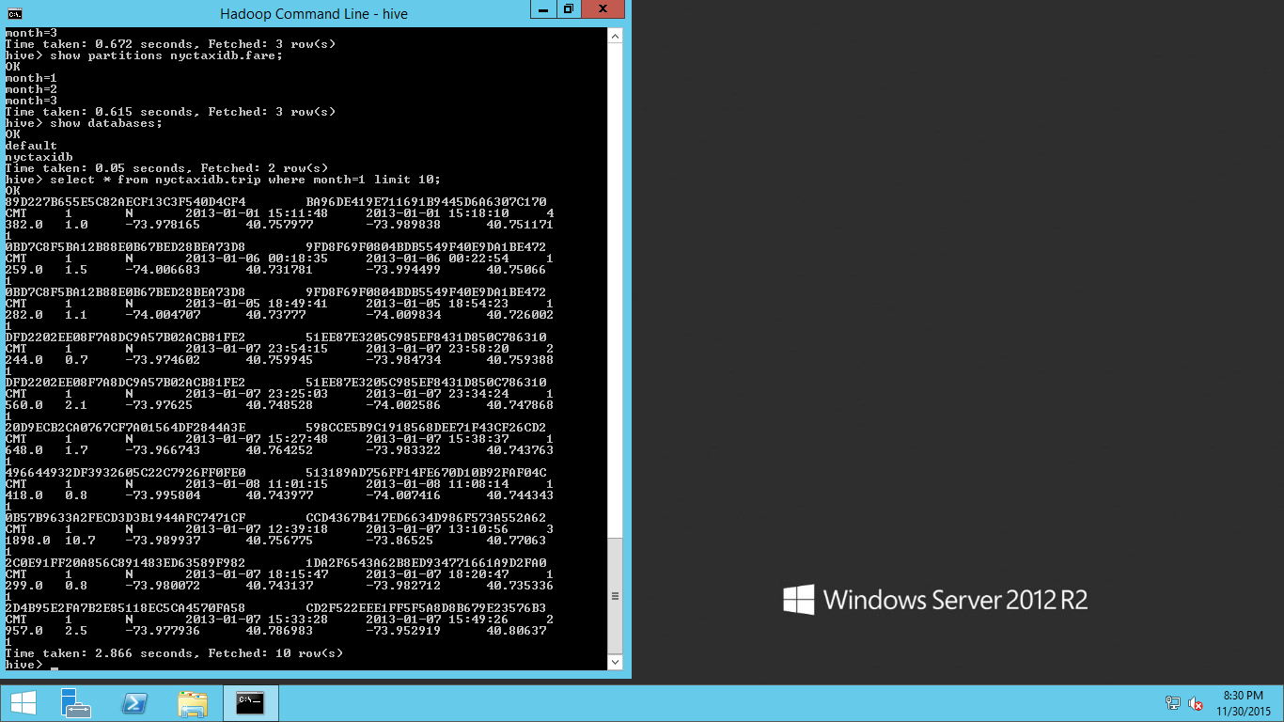

For month 1 fare table 10 records

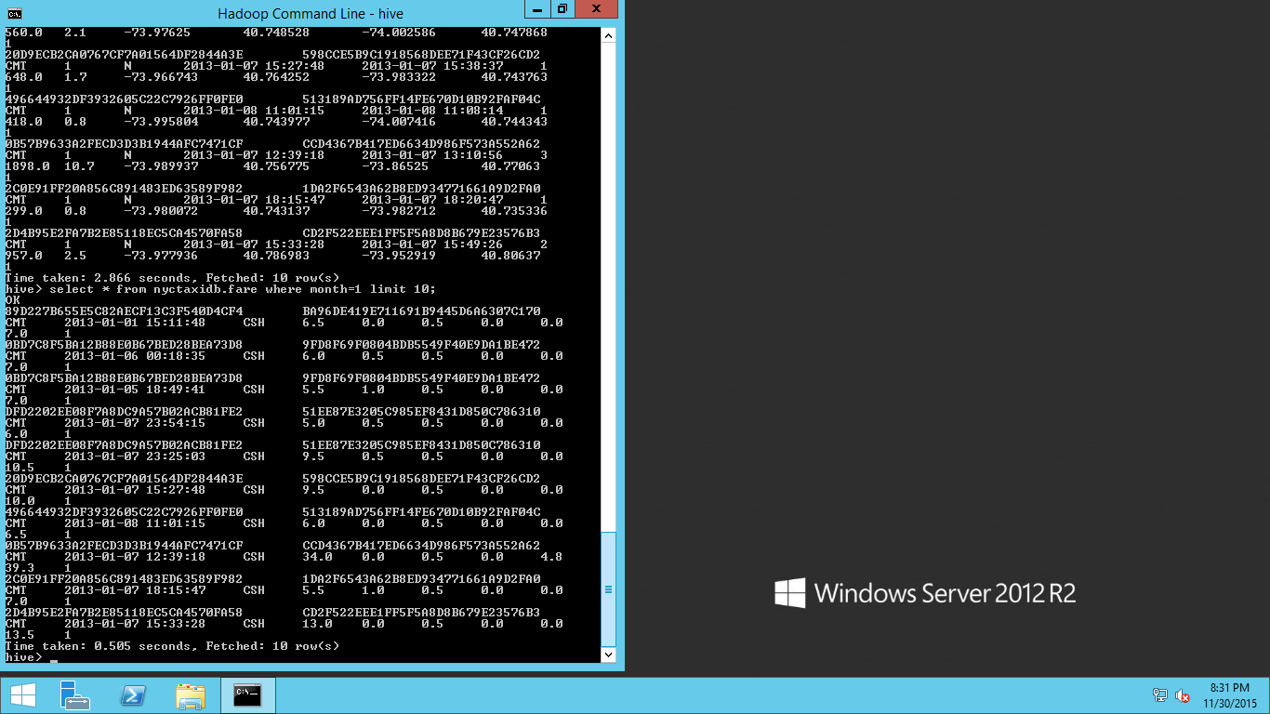

**Exploration: View the number of records in each of the 12 partitions**

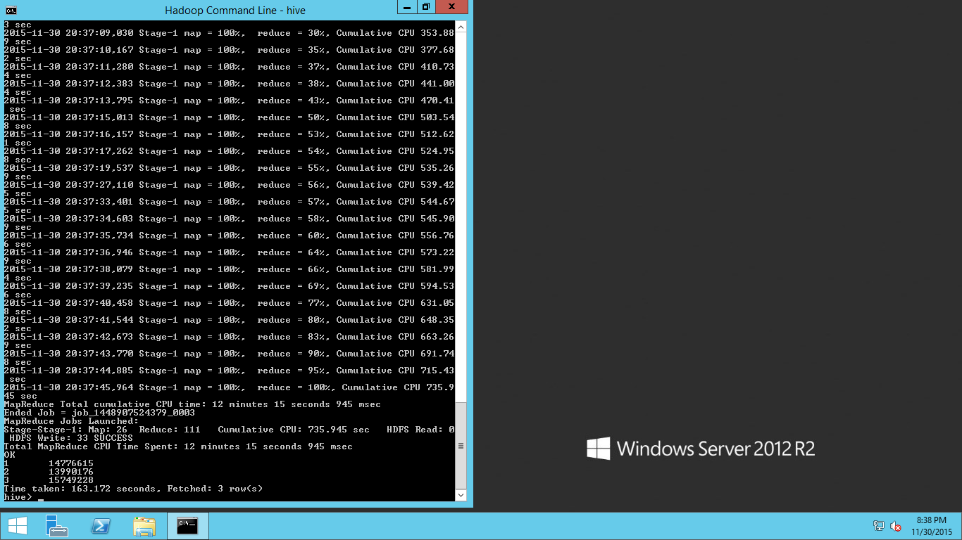

count the total number of records in our trip data set for 3 months

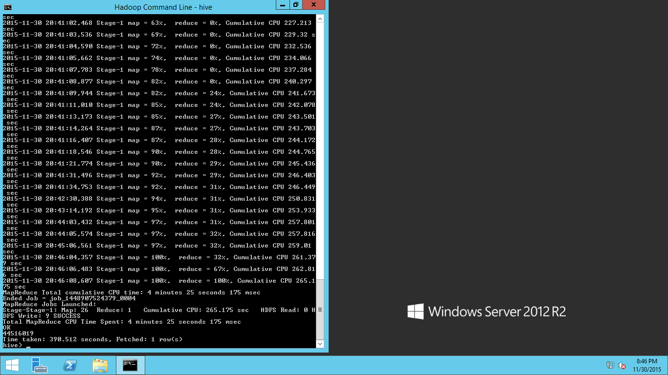

select month, count(*) from nyctaxidb.fare group by month;

**shows month and fare for 3 months**

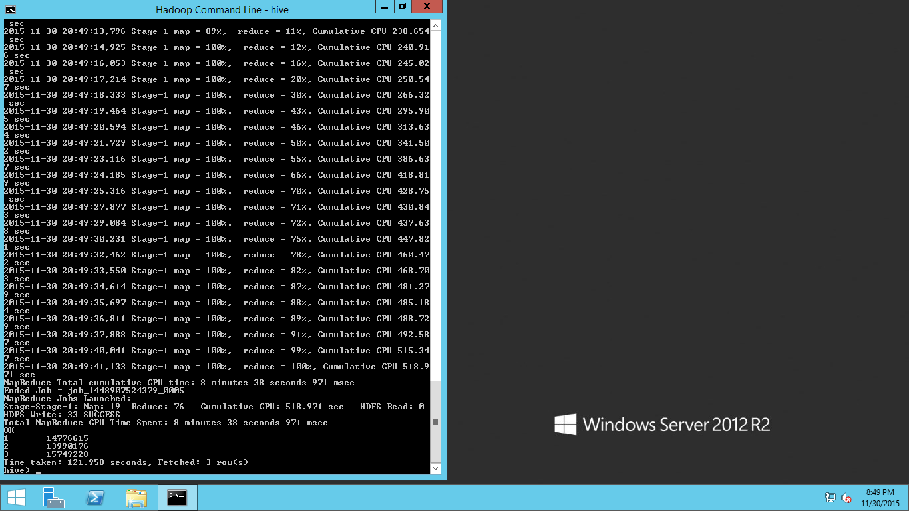

Note that the exact same number of trips per month is returned for both data sets. This provides the first validation that the data has been loaded correctly

Total count number of records

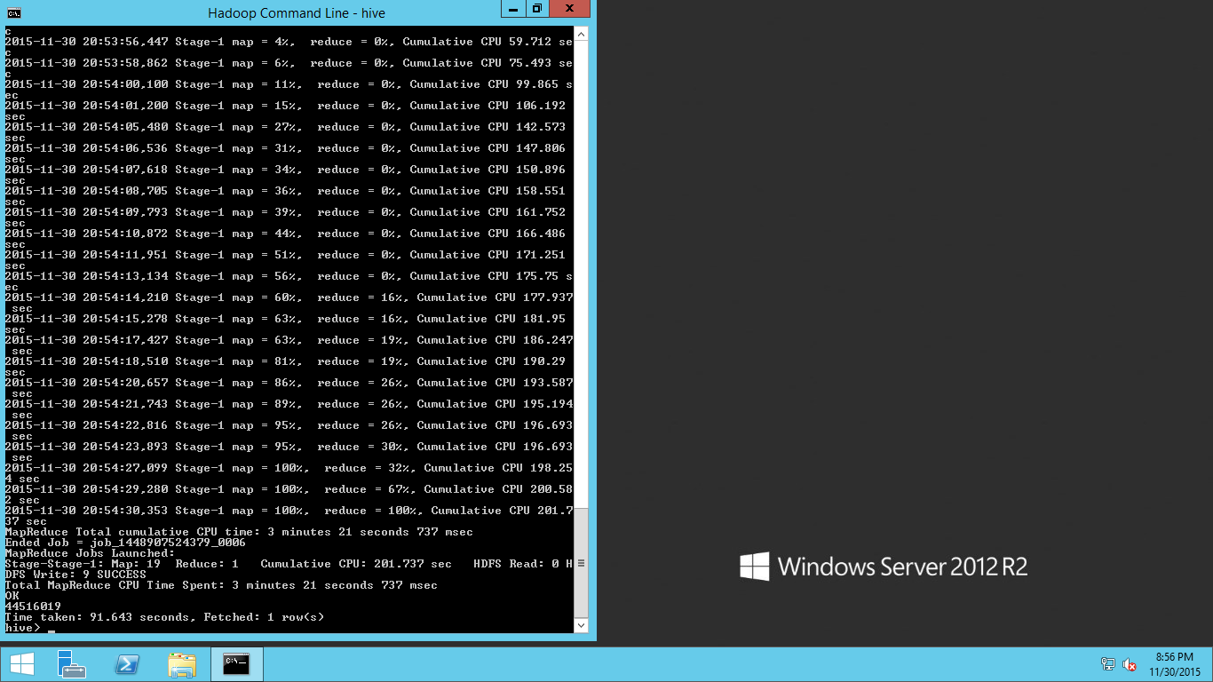

hive -f "C:\temp\sample_hive_trip_count_by_medallion.hql" > C:\temp\queryoutput.tsv

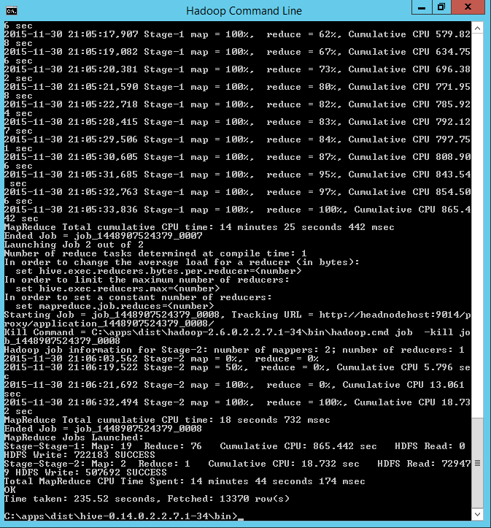

SELECT medallion, COUNT(*) as med_count

FROM nyctaxidb.fare

WHERE month<=3

GROUP BY medallion

HAVING med_count > 100

ORDER BY med_count desc;

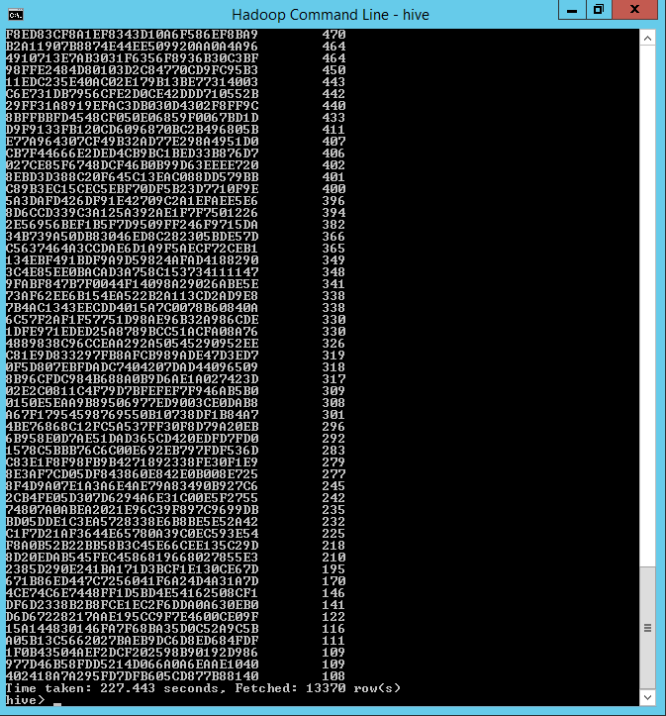

SELECT medallion, COUNT(*) as med_count

FROM nyctaxidb.fare

WHERE month<=2

GROUP BY medallion

HAVING med_count > 100

ORDER BY med_count desc;

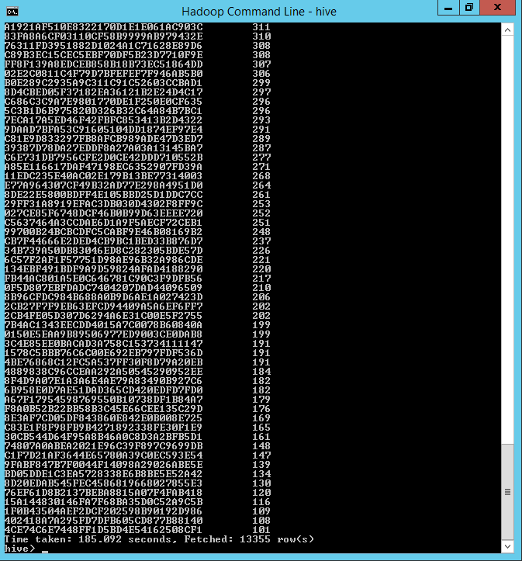

SELECT medallion, hack_license, COUNT(*) as trip_count

FROM nyctaxidb.fare

WHERE month=1

GROUP BY medallion, hack_license

HAVING trip_count > 100

ORDER BY trip_count desc;

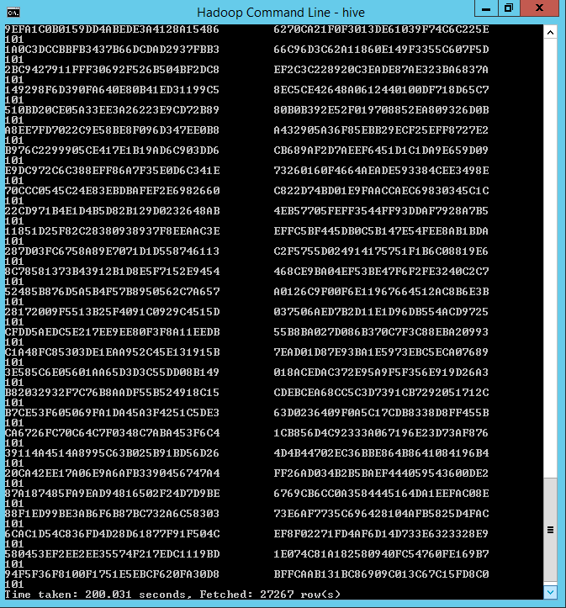

### Exploration: Class distributions in the multiclass setting

SELECT tip_class, COUNT(*) AS tipfreq

FROM

(

SELECT if(tip_amount=0, 0,

if(tip_amount>0 and tip_amount<=5, 1,

if(tip_amount>5 and tip_amount<=10, 2,

if(tip_amount>10 and tip_amount<=20, 3, 4)))) as tip_class, tip_amount

FROM nyctaxidb.fare

)tipclass

GROUP BY tip_class;

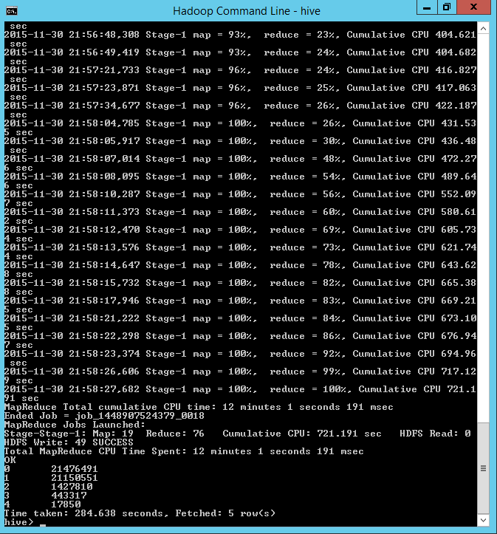

SELECT tipped, COUNT(*) AS tipfreq

FROM

(

SELECT if(tip_amount > 0, 1, 0) as tipped, tip_amount

FROM nyctaxidb.fare

)tipclass

GROUP BY tipped;

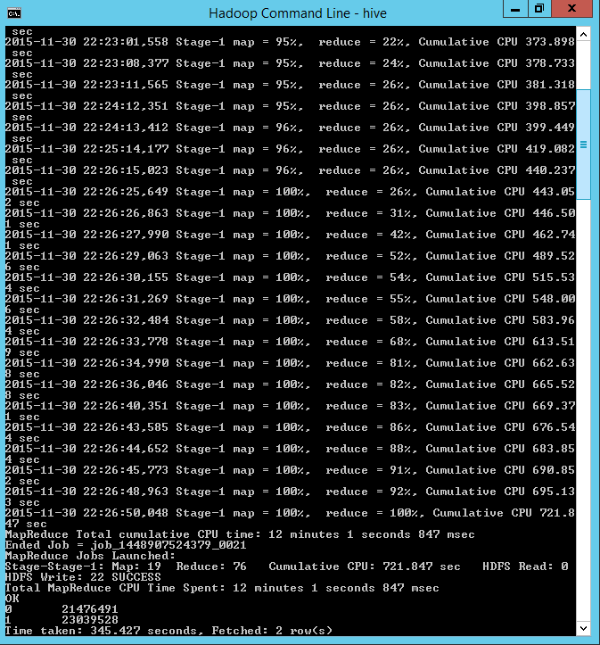

set R=3959;

set pi=radians(180);

select pickup_longitude, pickup_latitude, dropoff_longitude, dropoff_latitude, trip_distance, trip_time_in_secs,

${hiveconf:R}*2*2*atan((1-sqrt(1-pow(sin((dropoff_latitude-pickup_latitude)

*${hiveconf:pi}/180/2),2)-cos(pickup_latitude*${hiveconf:pi}/180)

*cos(dropoff_latitude*${hiveconf:pi}/180)*pow(sin((dropoff_longitude-pickup_longitude)*${hiveconf:pi}/180/2),2)))

/sqrt(pow(sin((dropoff_latitude-pickup_latitude)*${hiveconf:pi}/180/2),2)

+cos(pickup_latitude*${hiveconf:pi}/180)*cos(dropoff_latitude*${hiveconf:pi}/180)*

pow(sin((dropoff_longitude-pickup_longitude)*${hiveconf:pi}/180/2),2))) as direct_distance

from nyctaxidb.trip

where month=1

and pickup_longitude between -90 and -30

and pickup_latitude between 30 and 90

and dropoff_longitude between -90 and -30

and dropoff_latitude between 30 and 90;

**output: queryoutputdir**

hdfs dfs -ls wasb:///queryoutput_direct_distance

